Learning intention- To solve division problems.
Sam has 10 sandwiches and 5 plates. He shares them equally. How many will be on each plate?
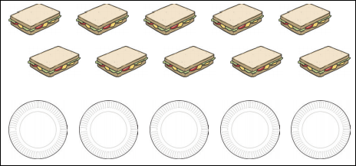

Sajay has 10 books. He shares them between 2 bags. How many will be in each bag?
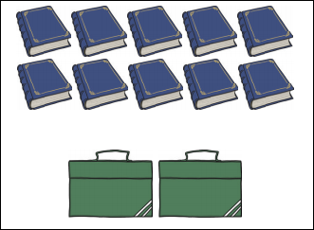

You have 25 jumpers and 5 bags. Share them equally, how many will be in each bag?
