Learning intention: To learn about time.
Yesterday we learnt where to draw the hands on a clock to say a time. Can you draw the hands on the clocks below to show the time?

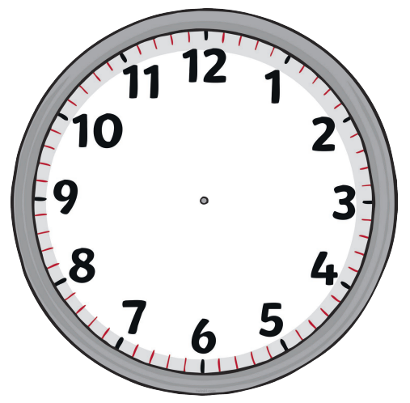
9 o’clock
4 o’clock
6 o’clock
1 o’clock
12 o’clock
10 o’clock
2 o’clock
3 o’clock
7 o’clock

