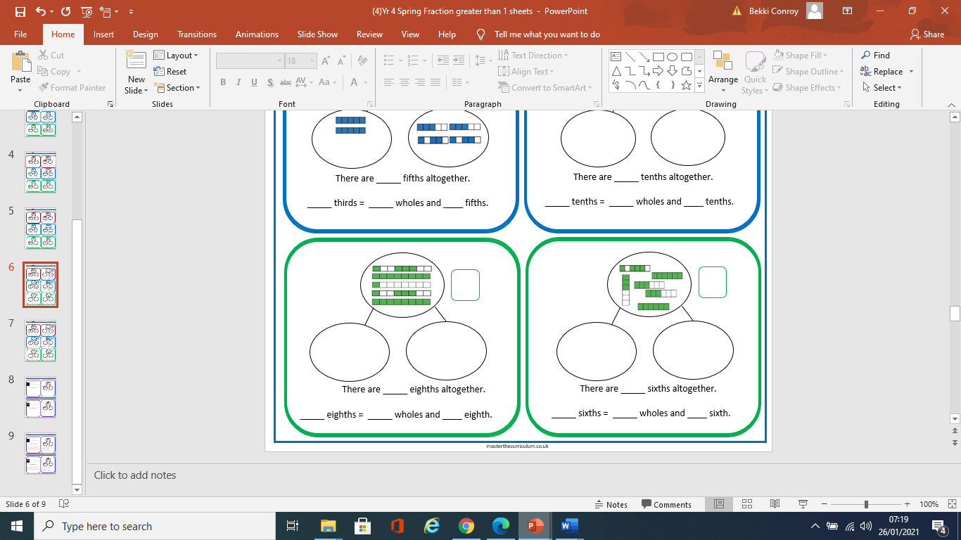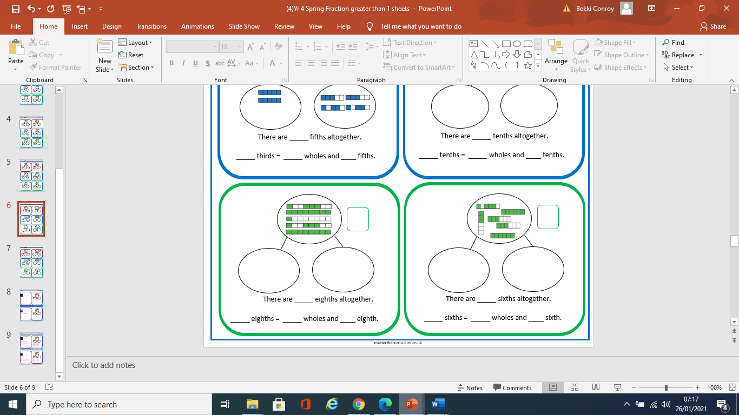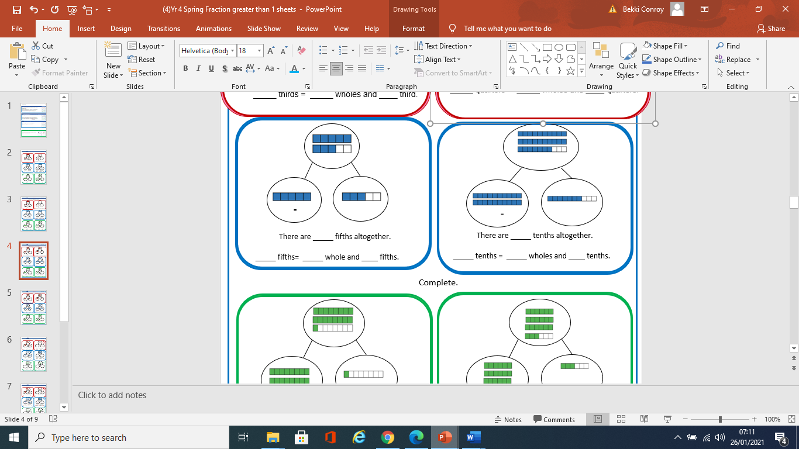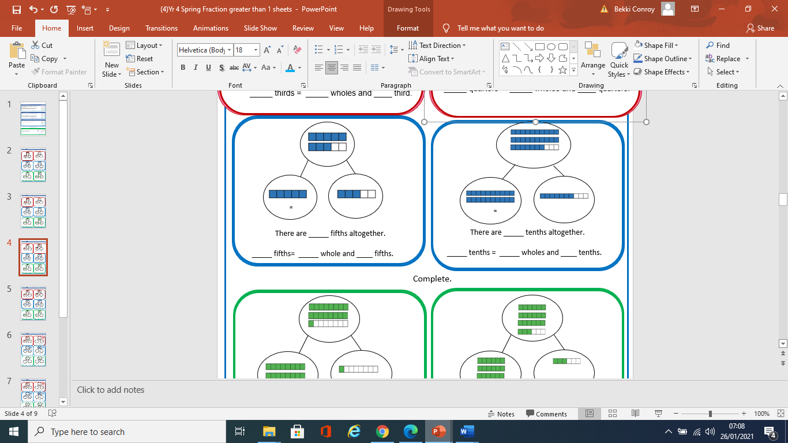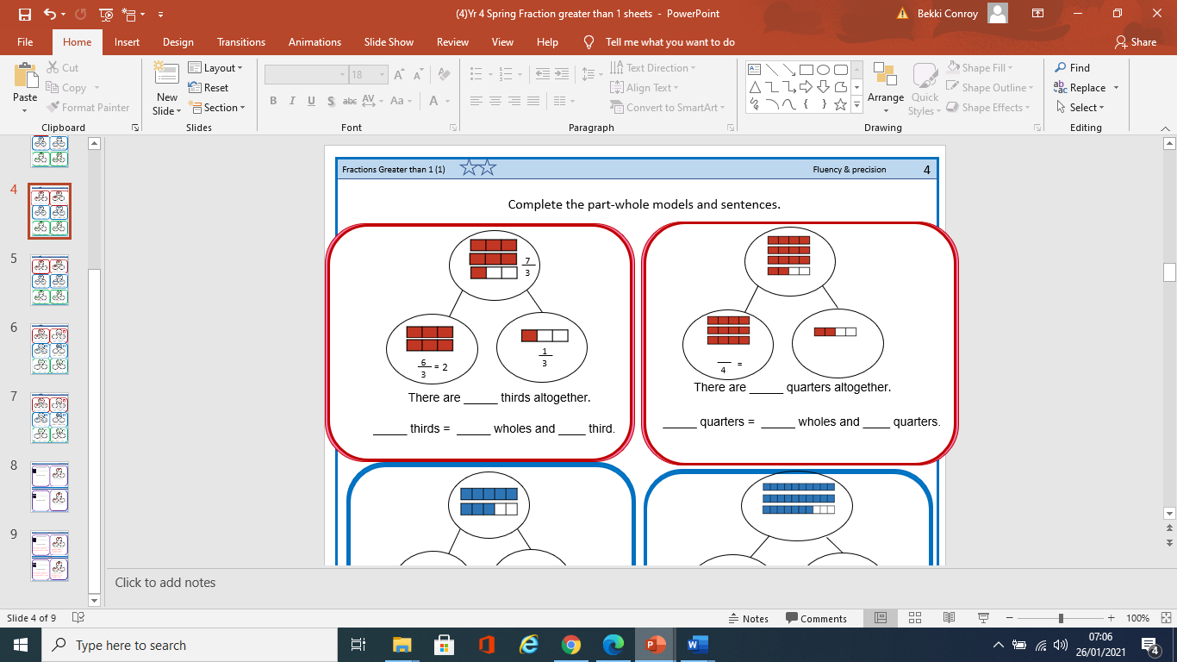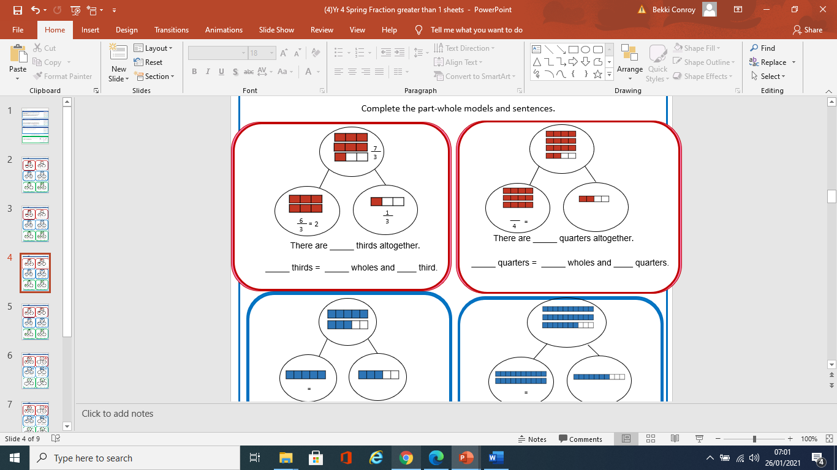

To recognise fractions can be split into wholes and parts

_____ sixths = _____ wholes

and ____sixth.

There are _____ sixths altogether.

_____ eighths = _____ wholes and _eighth.

There are _____ eighths altogether.

_____ tenths = _____ wholes and _

tenth.

There are _____ tenths altogether.

_____ fifths = _____ wholes and ___fifth.

There are _____ fifths altogether.

_____ quarters = _____ wholes and ____ quarter.

There are _____ quarters altogether.

_____ thirds = _____ wholes and ____ third.

There are _____ thirds altogether.

_____ tenths = _____ wholes and ____ tenth.