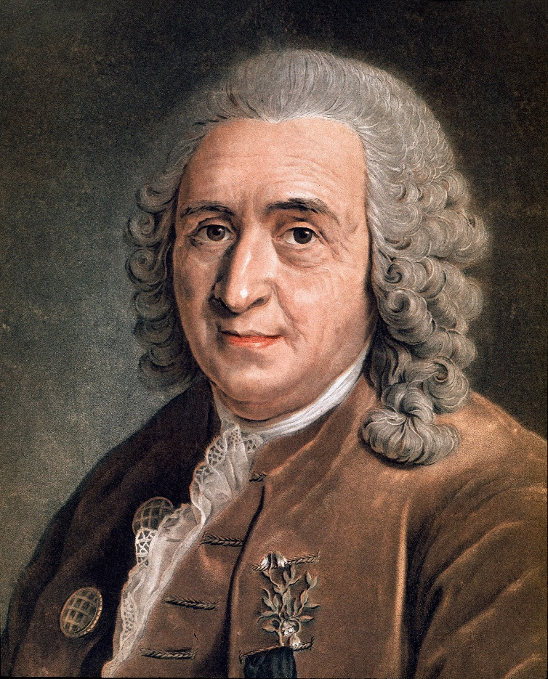
Carolus Linnaeus
Carolus Linnaeus, also known as Carl Linnaeus, was a scientist famous for his work in organising, or classifying, living things into groups. This is also known as taxonomy. He was born in Sweden in 1707. Much of his work is still used today.
When he was young, Carolus loved nature and especially plants. He enjoyed working with his father in the garden and loved to plant the gardens as well. He was a smart student but found his classes rather boring compared to being outside with plants.
Linnaeus went to university, then to medical school, and became a doctor in only two weeks! He proved in that short time that he knew a great deal about medicine.
He is famous for creating a two-part naming system. For example, when we refer to humans as Homo sapiens, we are using Linnaeus’s system using two names. Carolus also write two famous books about nature and plants.
Due to his amazing contributions to science, Carolus was made a knight by the King of Sweden in 1761. Much of his work is still used by scientists today.

Interesting Facts:
- Linnaeus was the first scientist to place humans with primates in the same family group.
- He was one of the first to study ecology as a science.
- Linnaeus’s study expeditions encouraged Darwin and Wallace to make scientific expeditions.
- He invented index cards to keep track of his specimens.

