Reading- To answer the comprehension questions based on a fictional text.

1. Circle the correct option to complete each sentence below.
(a) The text begins with Martine going out to ride her giraffe...
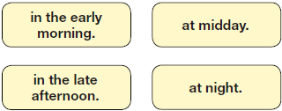

(b) Martine rode her giraffe.
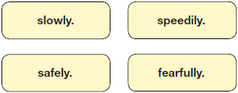

(c) Everything was fine on that day until...
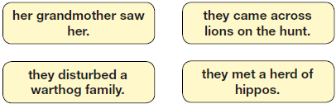
(d) At the end of the text, Martine...
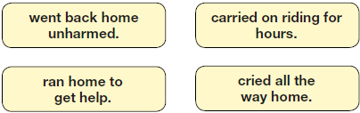

2. Look at the first paragraph, beginning: Dawn was casting...
How do you know that Martine wanted to keep this ride a secret?
______________________________________________________________
______________________________________________________________

3. What were Martine’s grandmother’s rules about riding the giraffe?

Tick two.
Ride only in daylight.
Don’t show off.
Stay in the game reserve.
Keep to a slow speed.
No jumping.

4. (a) What evidence is there of Martine being stubborn in the way she behaved with her grandmother?
Give two points.
1. _______________________________________________________
_________________________________________________________
2. _______________________________________________________
_________________________________________________________

(b) What evidence is there of Martine being determined when she met the warthogs?
_________________________________________________________
_________________________________________________________

5. ...milled around in bewilderment (page 3)
Explain what this description suggests about the baby warthogs.
______________________________________________________________
______________________________________________________________
______________________________________________________________

6. What evidence in the text is there that warthogs can be dangerous?
Give two examples.
1. ____________________________________________________________
2. ____________________________________________________________

7. What helped Martine to get safely on Jemmy’s back after the warthog’s attack?
______________________________________________________________
______________________________________________________________

8. The warthog mother made grunts of triumph (page 3)
Why was she triumphant?
______________________________________________________________
______________________________________________________________
9. Do you think that Martine will change her behaviour on future giraffe rides?

Tick one.
yes
no
maybe
Explain your choice fully, using evidence from the text.

10. In what ways might Martine’s character appeal to many readers?
Explain fully, referring to the text in your answer.

11. Draw lines to match each part of the story with the correct quotation from the text.
