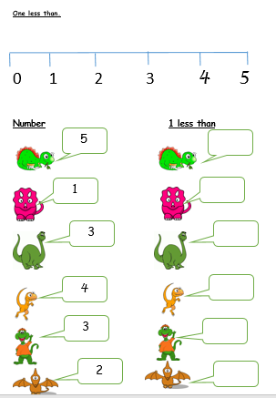

**2**

**4**

1

**3**

**4**

2

1 more than

One More Than