Year 6 Alternative Learning (2.3.21)

Exercise
Push up and sit up challenge! See how many push ups you can complete in 1 minute. Use the diagram below to help you, remember you can go on to your knees rather than your toes if it is too hard! Now see how many sit ups you can complete in 1 minute. Again, use the diagram below to help you.
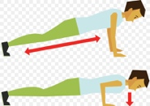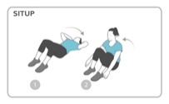
English
Learning intention: To use a range of grammar terms
Look at the grammar terms and their meanings to remind yourself what each of them mean. Answer the grammar questions on the worksheet.
Maths
Learning Intention: To use short division to divide numbers.
Work through the PowerPoint to carry out short division with carrying and then with remainders.
Geography
Learning Intention: To analyse how population is distributed across the world.
Look at the pie chart which shows the world population in 2017.
Answer the true or false statements using the Pie Chart.
Reading –  Learning Intention: To read a non-fiction text about planets and answer comprehension questions. | Remember school website is:  http://www.moorside.newcastle.sch.uk/website  If stuck or want to send completed work then email  linda.hall@moorside.newcastle.sch.uk

