Maths Day 3 – 2D shapes
Which 2D shapes can you spot in the picture?

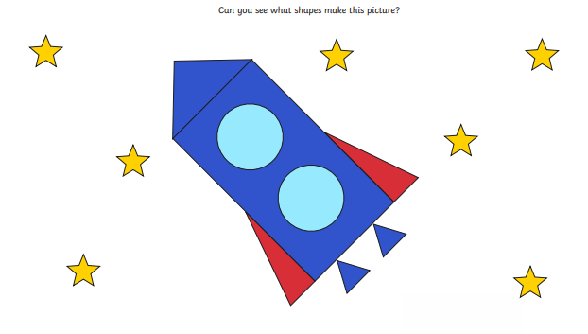

Can you draw any 2D shapes you can see at home?

