To identify the points of a compass.

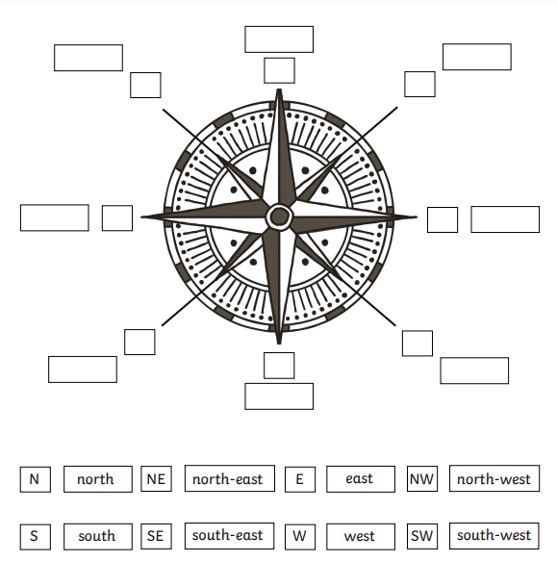

w

S w

S

S E

E

N E

N

N W