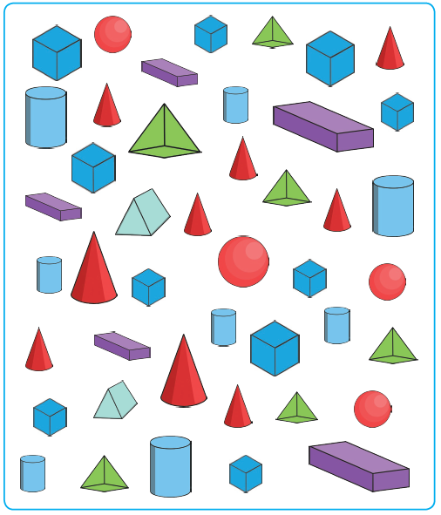
Maths – 3D Shapes – Cubes, cuboids and square based pyramids
Find the shapes and fill in the table below. If you’re finished, check the powerpoint for an extra challenge!

cubes

cuboids

pyramids

