Fantastic Mr Fox
Chapter 5
The Terrible Tractors
Task 1
Questions for chapter
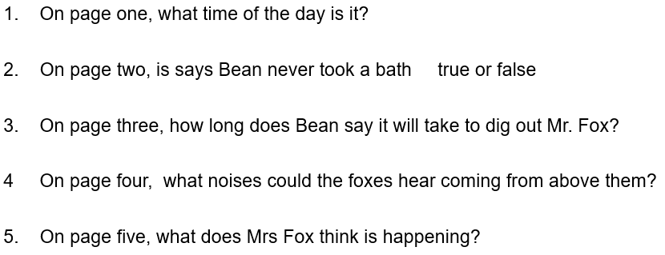
Answer your questions like this.
Q1 It is ___________________________________________________________.
Q2 Mr. Bean _______________________________________________________.
Q3 Mr. Bean says ___________________________________________________.
Q4 The foxes could hear_________________________________coming from above them.
Q5 Mrs. Fox thinks that _______________________________________________.

Task 2
Do a drawing of your favourite part so far. Add a caption to the drawing to explain what it shows. You could choose a sentence from the text as a caption. Use one of the examples below or choose one of your own.
For example;
‘Soon, two enormous caterpillar tractors with mechanical shovels on their front ends came clanking into the wood.’
‘The machines went to work, biting huge mouthfuls of soil out of the hill.’
‘Down in the tunnel the foxes crouched, listening to the terrible clanging and banging overhead.’

