Year 2 (Monday 1.3.21)
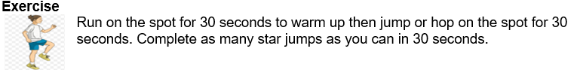
English
Learning intention: to explore possessive apostrophes.

Use the PowerPoint to remind you what apostrophes are and learn how to use them to show possession e.g. Mum’s, dragon’s, giant’s. Then fix the sentences on the sheet by adding possessive apostrophes. Challenge: write a sentence for each of the final pictures, including an apostrophe for possession somewhere in the sentence.

Alternative 1: Use the PowerPoint to remind you what apostrophes are and learn how to use them to show possession e.g. Mum’s, dragon’s, giant’s. Then fix the sentences by adding possessive apostrophes.
Alternative 2: Use the PowerPoint to learn about apostrophes. Then add apostrophes to the simple sentences.

Spelling: house where there

Handwriting: using the PowerPoint, practise writing ‘ew’. Alternative 1: practise writing ‘ee’. Alternative 2: practise writing ‘b’.

Reading
Blue and grey: Read the non-fiction text about Australian animals.
Orange and yellow: Read the story ‘A mouse in the house’.

Alternative reading
Pink and purple: Use the worksheet to read some of the words that will be in your new text.
Red and green: Look at the picture and write the word.
Maths
Learning intention: To solve multiplication problems.

Look at the PowerPoint showing ways to solve multiplication problems. Then solve the problems on the worksheet showing your working out.

Alternative 1: Look at the Alternative 1 maths PowerPoint showing how to solve multiplication problems using the 10 and 2 times tables. Use this knowledge to complete the worksheet.
Alternative 2: Complete the worksheet using your knowledge of the 10 times table.

Art Learning intention- To learn about different artists.
Look at the PowerPoint about JMW Turner and talk about his paintings.

Remember school website is: http://www.moorside.newcastle.sch.uk/website
If stuck or want to send completed work then email linda.hall@moorside.newcastle.sch.uk

