Maths
LO: To multiply whole numbers by 10
9 x 10 =
45 x 10 =
63 x 10 =
2 x 10 =
12 x 10 =
374 x 10 =
84 x 10 =
10 x 10 =
126 x 10 =
50 x 10 =
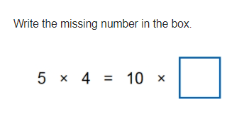

True or False?
35 x 10 = 530
Circle the answer to forty-nine multiplied by ten.
940 4910 490 4900

