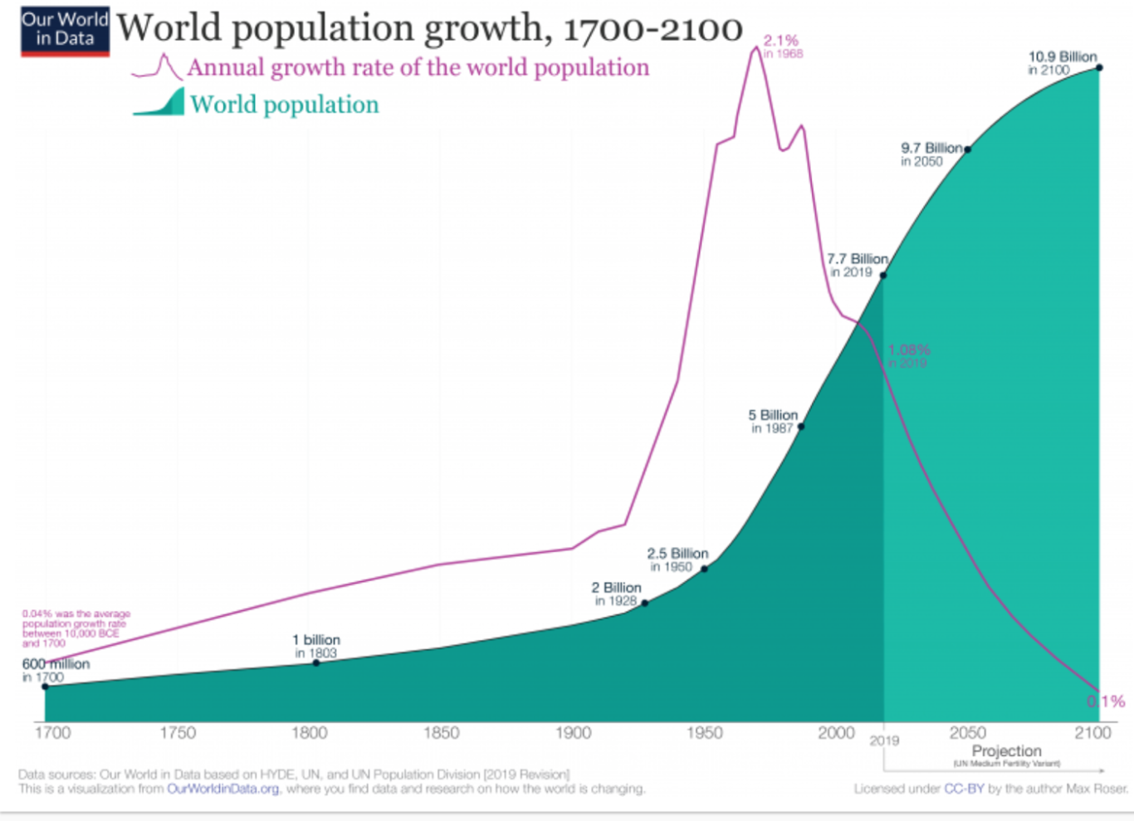
Geography Learning intention – To observe and understand world population over time
Look at the graph below. Analyse the information to help you to answer the questions below.

- In 1800 the population of the world was 1 billion? Is this statement true or false?

- In which year was the population 2 billion?

- In 1987 the population was 4 billion? Is this statement true or false?

- In which year was the population 7.7 billion?

- By how much will the population grow from 2019 to 2050?

- What will the population be by 2100?

