Maths task one
Linked to addition and subtraction of more than one number
Complete exercise 11.
*If extra support is needed, find 20 objects (toys, pencils, raisins etc.) and use these to make addition sentences with just two numbers (for example, 11 + 3 = )

Maths task two
Make equal groups https://whiterosemaths.com/homelearning/year-2/week-12-number-multiplication-division/
Watch the video and answer the questions or use the questions below.

Repeated additions Describe the groups Challenge: what do you notice about these groups?
2+2+2=
2+2+2+2=
3+3+3+3=
10+10=
5+5+5+5+5=

*If extra support is needed, practise counting in 10s and making groups of 2 or 10 using objects or by drawing.

Maths task three
Make equal groups from unequal groups (redistribute activity) https://whiterosemaths.com/homelearning/year-2/week-12-number-multiplication-division/
Make these groups equal.

You can make unequal groups by moving objects one at a time.
How many different ways can you put 8 into 2 groups? Draw as many different ways as you can.

E.g. 4 + 4 = 8

Try this practically with 12 objects. How many different equal groups can you make?

Maths task four
Add equal groups https://whiterosemaths.com/homelearning/year-2/week-12-number-multiplication-division/
Write a repeated addition sentence.

Challenge: can you write a multiplication sentence to go with these?
Challenge 2: draw your own pictures using 2s, 5s, 10s or 3s. Can you write number sentences to go with them?

Maths task five
Make arrays https://whiterosemaths.com/homelearning/year-2/week-12-number-multiplication-division/
Starter:

Arrays explained:

3 + 3 + 3 = 9
3 X 3 = 9

Draw arrays to answer these repeated addition sentences.
2+2+2+2+2+2+2 =

5+5+5+5+5+5 =

10+10+10=

3+3+3+3+3+3+3+3+3+3=

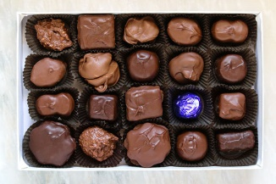
Write a repeated addition (or as a challenge, a multiplication sentence!) for these arrays.

