Day Two - Grammar – conjunctions
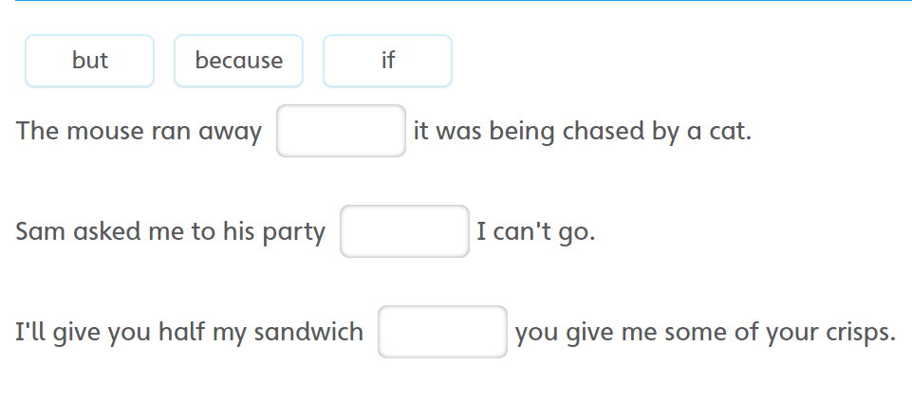
Use the conjunctions below to complete the sentences.

Co-ordinate sentences using and, or, but
Complete the sentences with the correct conjunction
and or but
- I have played outside in the field _____ my clothes are dirty.
- Should we go on the bus ___ go in the car?
- Jo picked up all of her toys ____ her room was still messy.

Complete these sentences using one of the three conjunctions from above.
Would you like to do some painting or __________________ ?
Holly wanted to go to the park but ___________________.
Jim tripped over and ________________ .

Write your own sentences with and, but, or in them.
- and ____________________________________________
- but ____________________________________________
- or _____________________________________________

