Reading – Alternative 1

Read the sounds in and out of order.
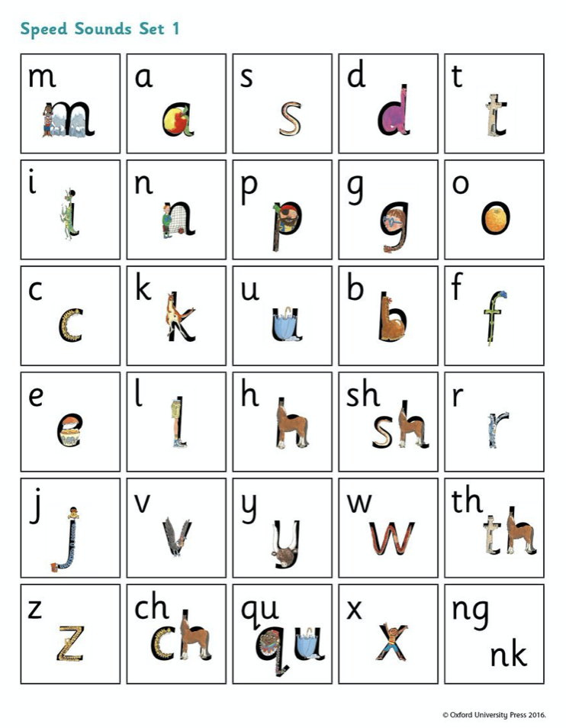

Challenge: Choose 4 sounds to think of as many words that start with the sound!

