Year 1 Learning (04.02.21)
Motor skills  Pretend you have maracas, shake your hands in front of you. Go up and down, left and right. Can you shake them fast and slow?  Can you touch your toes? Go slowly and breathe slowly in as you go down, and out as you go up. |  | 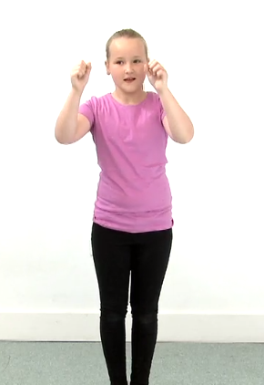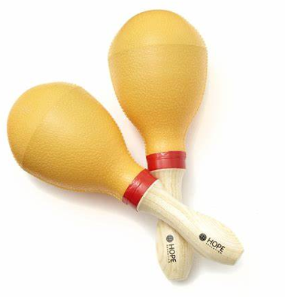
English
Learning intention: To retell a traditional tale.
- Use your story map and actions to retell the story.
- Can you retell your story using your voice in different ways? For example, in a whisper, in a song, to your family.
- Phonics: ow
- Handwriting: ee

Alternative English:
- Use your story map and actions to retell the story.
- Can you retell your story using your voice in different ways? For example, in a whisper, in a song, to your family.
- Phonics: u
- Handwriting: a

Maths
Learning intention: To work with number bonds.
- Today we are going to be learning about subtraction number bonds to 20.
- Look back at yesterday’s PowerPoint and complete the worksheet.
- Listen and sing along to the number bond song: https://www.bbc.co.uk/teach/supermovers/ks1-maths-number-bonds-with-martin-dougan/zf6cpg8
Alternative maths 1
- Today we are going to be learning about subtraction number bonds to 10.
- Look back at yesterday’s PowerPoint and complete the worksheet.
- Sing along with this song to practice counting to 10: https://www.bbc.co.uk/teach/school-radio/nursery-rhymes-1-2-3-4-5-once-i-caught-a-fish-alive/zdy6jhv
Alternative maths 2
- Watch this video and sing along: https://www.bbc.co.uk/teach/school-radio/nursery-rhymes-five-little-ducks-went-swimming-one-day/z43xwty
- Go through the PowerPoint and count up to 5.
- Practice counting to 5 using this game: https://www.topmarks.co.uk/learning-to-count/underwater-counting
Foundation - Music
Learning intention: To listen to and discuss different types of music.
- Go through yesterday’s PowerPoint again.
- Look at the worksheet and answer the questions with your grown up.
- Draw a picture of your favourite instrument.
Reading - Have a think about which colour book you are currently reading and read the book of that colour below.  Lilac - https://www.oxfordowl.co.uk/api/digital_books/1114.html  Red - https://www.oxfordowl.co.uk/api/digital_books/1285.html  Green - https://www.oxfordowl.co.uk/api/digital_books/1320.html  Purple - https://www.oxfordowl.co.uk/api/digital_books/1492.html  Pink - https://www.oxfordowl.co.uk/api/digital_books/1211.html  Orange - https://www.oxfordowl.co.uk/api/interactives/29298.html  Yellow - https://www.oxfordowl.co.uk/api/interactives/29303.html | Remember, the school website is:  http://www.moorside.newcastle.sch.uk/website  If you are stuck or want to send completed work then email:  linda.hall@moorside.newcastle.sch.uk

