Maths – Number bonds to 20
Can you fill in the missing numbers to make the number bonds to 20? Use the number line and the Numicon below to help you.

11 + ___ = 20 16 + ___ = 20

12 + ___ = 20 17 + ___ = 20

13 + ___ = 20 18 + ___ = 20

14 + ___ = 20 19 + ___ = 20

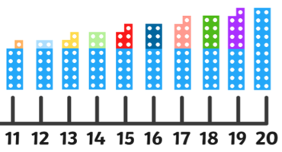
15 + ___ = 20 20 + ___ = 20

