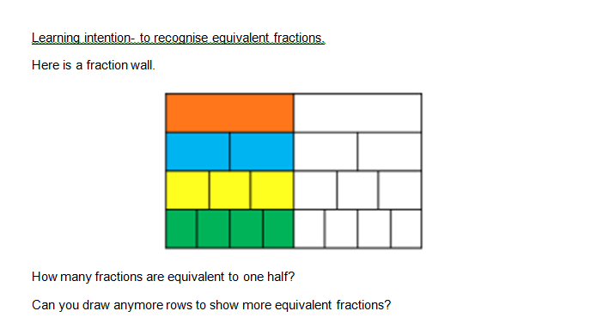

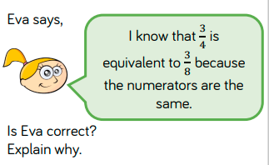

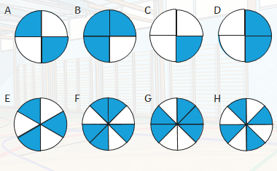

Alfie has drawn some shaded circles.

Which circles are equivalent to ½?

Write the equivalent fractions that each circle represents.