26.1.21 Alternative maths
Count in 2s
What pattern can you see?

Count in 10s
What pattern can you see? What number comes next?

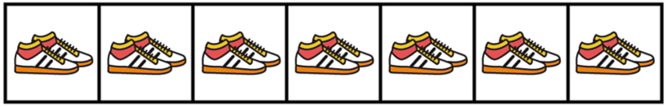
2s

2 4 6 ___ 10 12 ___

2 ___ 6 8 10 ___ 14 16 ___

___ 4 ___ 8 ___ 12 14 ___ 18 20

10s

10 20 ___ 40 50

___ 20 30 40 ___

