Maths Learning Intention: To solve word problems involving simplified fractions.
Remember when we simplify fractions whatever we do to the numerator (the top number) we do to the denominator (the bottom number).
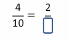In this example 4 has been divided by 2 therefore, 10 must also be divided by two to find the simplified fraction.
So, the answer would be 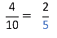
Use this method to solve these word problems.
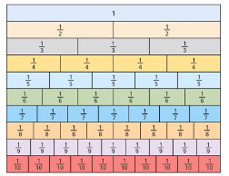
Use the fraction wall to find simplified fractions for
A pizza is split into 9 slices. Tommy and Olivia eat 6 slices of pizza. This is shown on the bar model below.
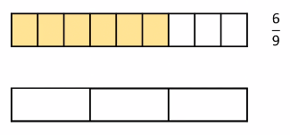
Shade the bar model to show this as a simplified fraction? What is the simplified fraction?
What method could you use to check your answer?
Courtney eats 12 sweets out of a pack of 16. This is shown in the bar model below. Simplify the fraction using the bar model.
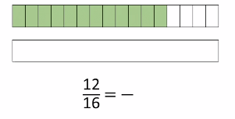
Now, simplify this fraction using common factors.

35 out of a class of 40 attended school today. Use common factors to show this fraction in its simplest for.
