Alternative Maths 1

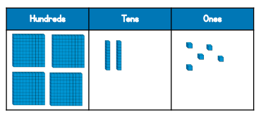
- Anna has made a number.
What number has Anna made?

Is it odd or even? How do you know?

b) Circle the number that has the digit 7 in the tens column?
725 572 257

c) Max is making a number using some counters. Max chooses 6 counters. He makes a number greater than 300. Circle the counters Max could have chosen.
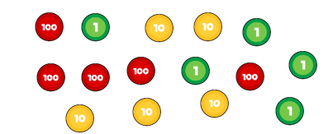

d) Match the numbers.
676
606
660
Six hundred and six
Six hundred and sixty
Six hundred and seventy-six

e) Complete the missing numbers
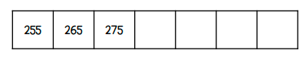

f) Here are some digit cards.
Max uses the cards to make a 3 digit number. Write down all the numbers between 250 and 550 Max can make.
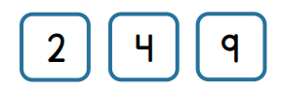

g) What is 100 less than 719? ___________
What is 10 more than 97? ___________
What is 10 less than 205? _____________

h) What number is the arrow pointing to?
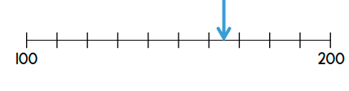
- How many tens are there in 500?
