Learning intention: to recognise mixed number fractions
Find the improper fraction:
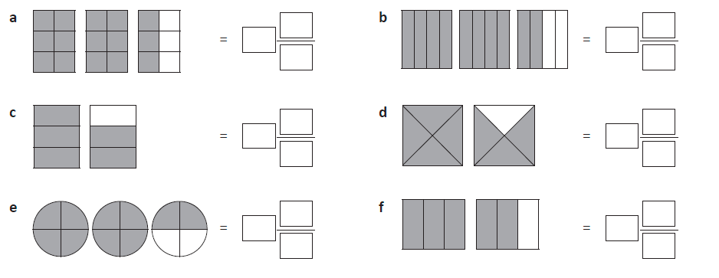

Draw the improper fraction:
