Halving amounts
Have a look at the questions below. Can you find half of each of the amounts by using sharing?
Remember when finding ½ we are sharing between 2 groups.
I have done the first one for you.

½ of 6 = 3 ½ of 10 = ½ of 18 = ½ of 24 = ½ of 12 =

Now use your understanding of finding ½ to complete the word problems below. Remember to use sharing to help you!
1. 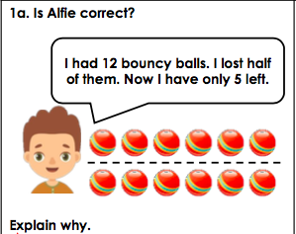 2. 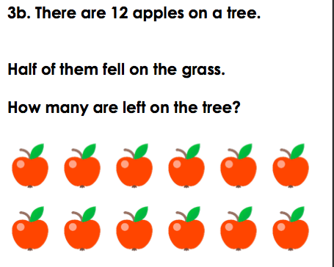

3. 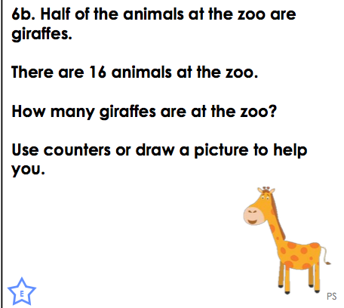 4. 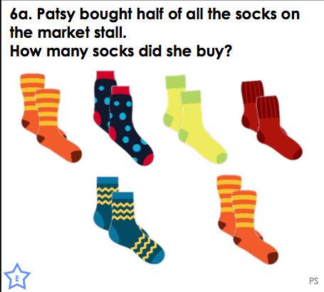

5. 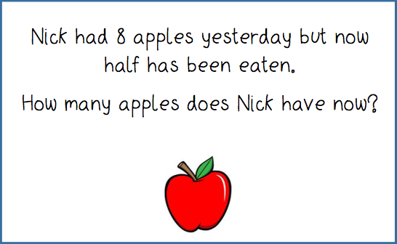 6. 