Subtracting using the column method
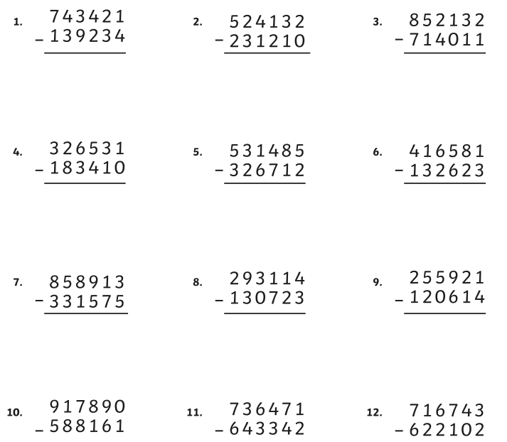

a) | 4.2 | - | 1.268 | =
b) | 41.81 | - | 2.78 | =
c) | 72.2 | - | 4.935 | =
d) | 816.7 | - | 9.627 | =
e) | 62.93 | - | 8.719 | =

