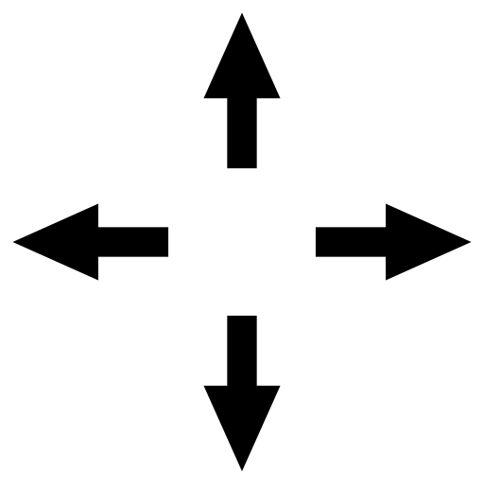**Maths**

**Learning Intention: To describe movement**

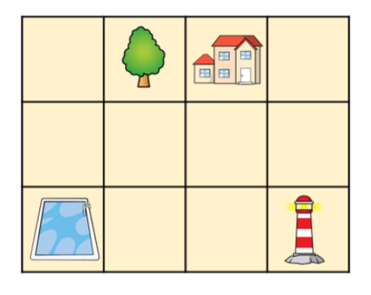

1. Start at the house. Go 2 steps down and 1 step right. Where are you?
2. Start at the tree. Go 1 step right. Where are you?
3. Start at the arrow. Go 3 steps up. Where are you?