Maths alternative 2
Learning intention: To order and arrange combinations of mathematical objects in patterns and sequences.

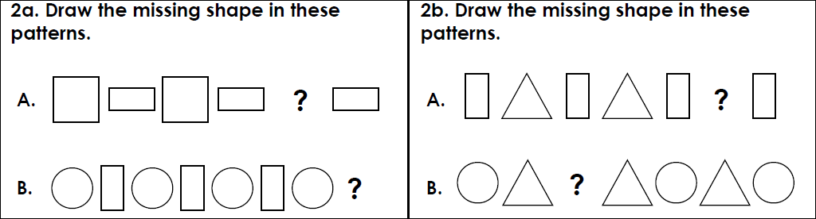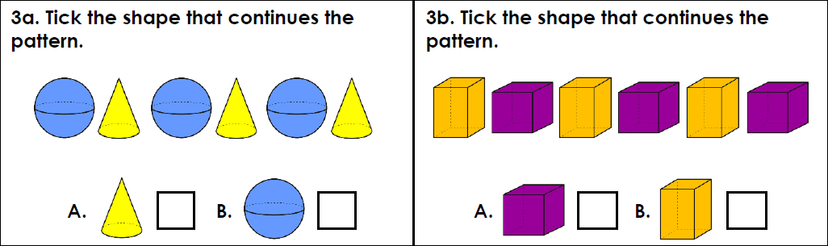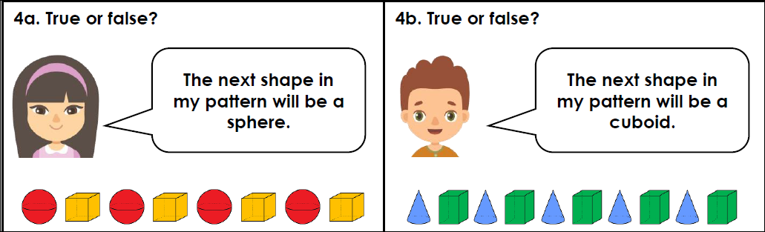

Challenge
