20.1.21
To multiply two digit numbers by a one digit number.

- 2 5 b) 6 1 c) 7 5 d) 8 1
X 3 x 4 x 5 x 2

2. Can you find the mistake?
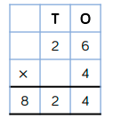 Can you make this multiplication correct?

3.
