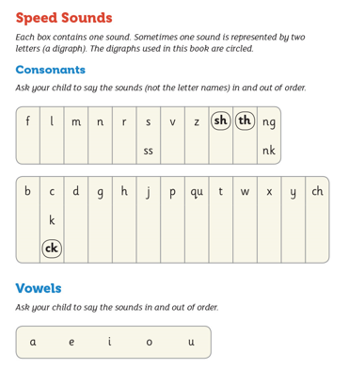
Speed Sounds
Practice the sounds in and out of order

