**Nursery Rhymes**

Baa, baa, black sheep

Baa, baa, black sheep  
Have you any wool?  
Yes, sir, yes, sir  
Three bags full  
One for the master,  
And one for the dame,  
And one for the little boy  
Who lives down the lane.

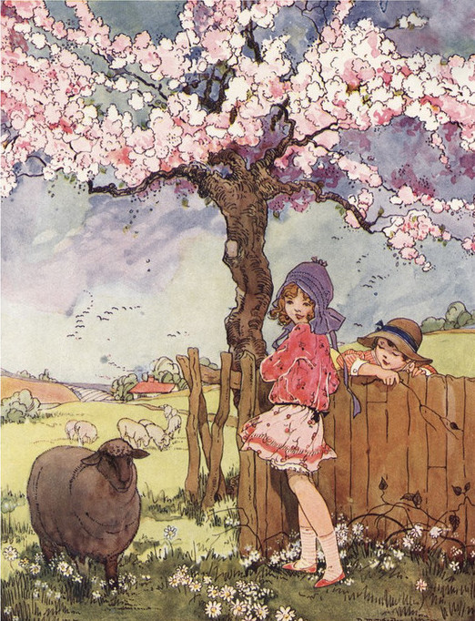

Humpty Dumpty sat on a wall,  
Humpty Dumpty had a great fall.  
All the king's horses and all the king's men  
couldn’t put Humpty together again.

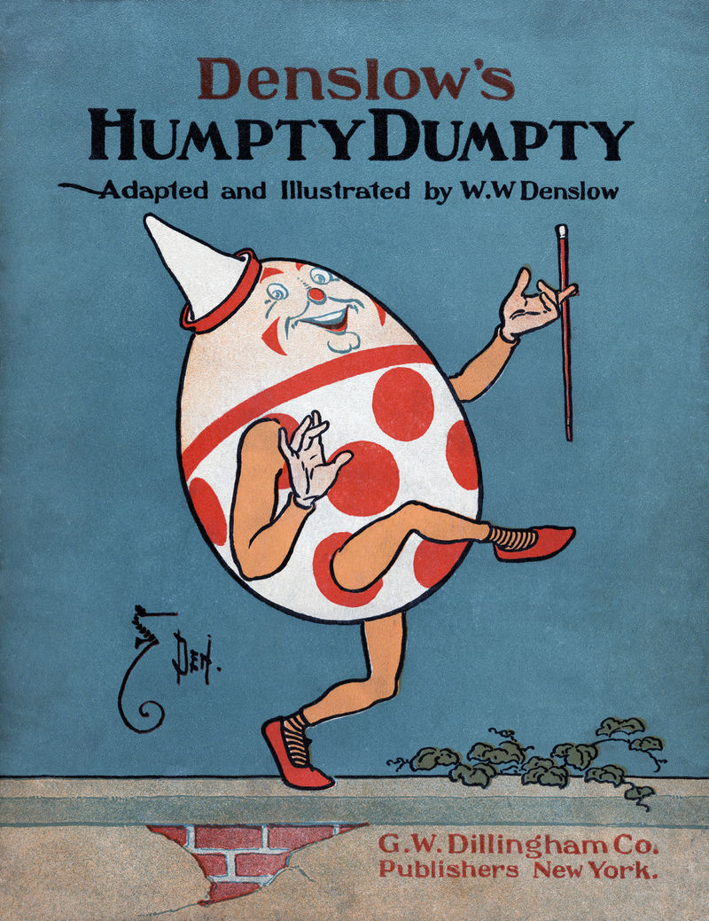

Humpty dumpty

5 Little speckled frogs

5 Little speckled frogs

5 little speckled frogs, sat on a speckled log eating the most delicious bugs yum yum. One jumped into the pool, where it was nice and cool then there was...4 green speckled frogs glub glub.

4 little speckled frogs, sat on a speckled log eating the most delicious bugs yum yum. One jumped into the pool, where it was nice and cool then there was...3 green speckled frogs glub glub.

3 little speckled frogs, sat on a speckled log eating the most delicious bugs yum yum. One jumped into the pool, where it was nice and cool then there was...2 green speckled frogs glub glub.

2 little speckled frogs, sat on a speckled log eating the most delicious bugs yum yum. One jumped into the pool, where it was nice and cool then there was...1 green speckled frogs glub glub.

1 little speckled frogs, sat on a speckled log eating the most delicious bugs yum yum. One jumped into the pool, where it was nice and cool then there was...no green speckled frogs glub glub.

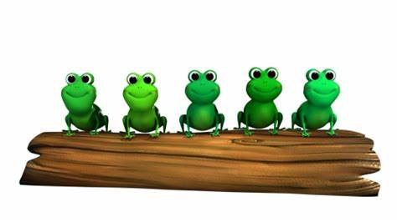

One Two Three Four Five

Two Little Dicky Birds

One Two Three Four Five

One, two, three, four, five, once I caught a fish alive.

Six, seven, eight, nine, ten. Then I let it go again.

Why did you let it go?

Because it bit my finger so. Which finger did it bite?

This little finger on my right.

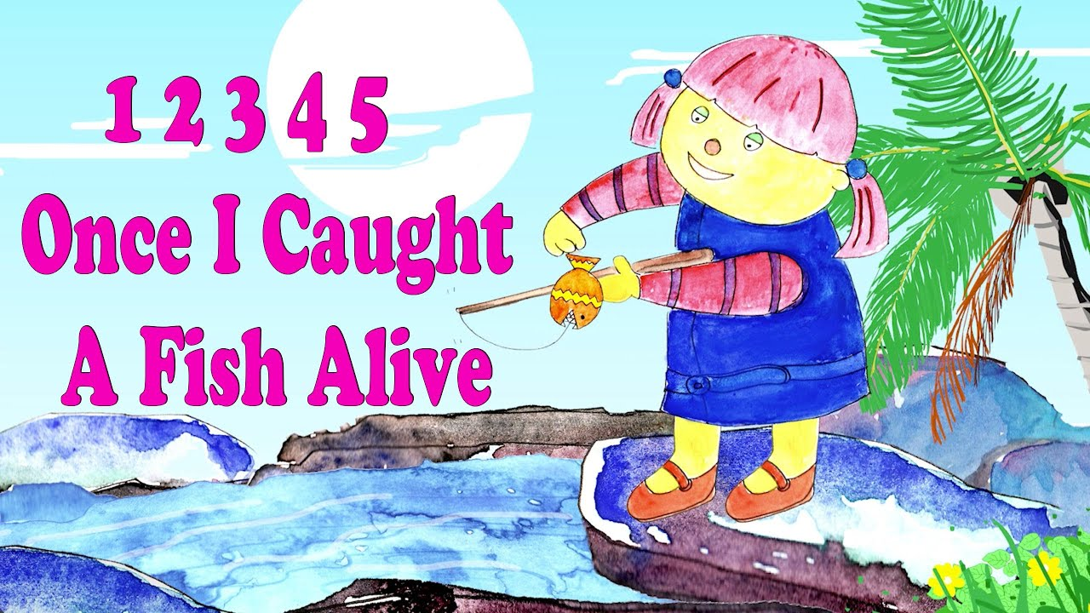

Two little dicky birds sitting on a wall.

One named Peter and one named Paul.

Fly away Peter, fly away Paul.

Come back Peter, come back Paul.

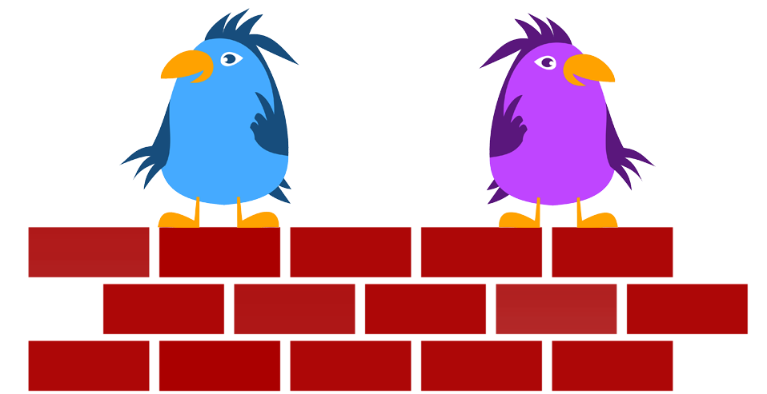

Incy Wincy Spider.

Incy Wincy spider climbed up the water spout.

Down came the rain and washed the spider out.

Out came the sunshine and dried up all the rain.

So the Incy Wincy spider climbed up the spout again.

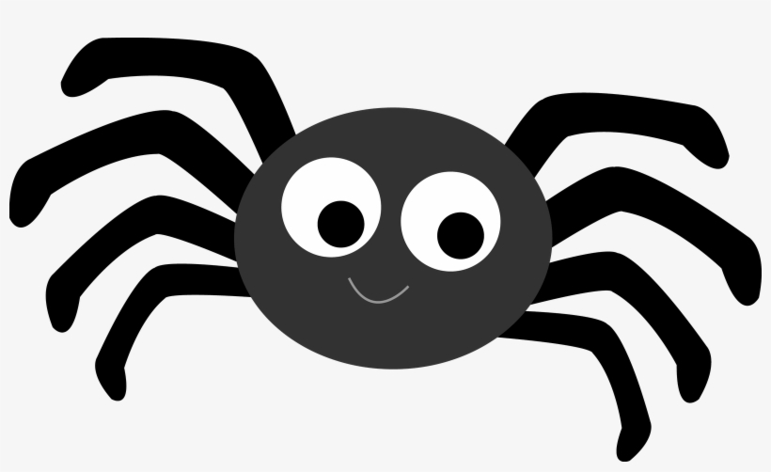

Baa Baa black sheep.

Baa Baa black sheep, how you any wool?

Yes sir yes sir three bags full.

One for the masrter and one for the dame and for the little boy who lives down the lane.

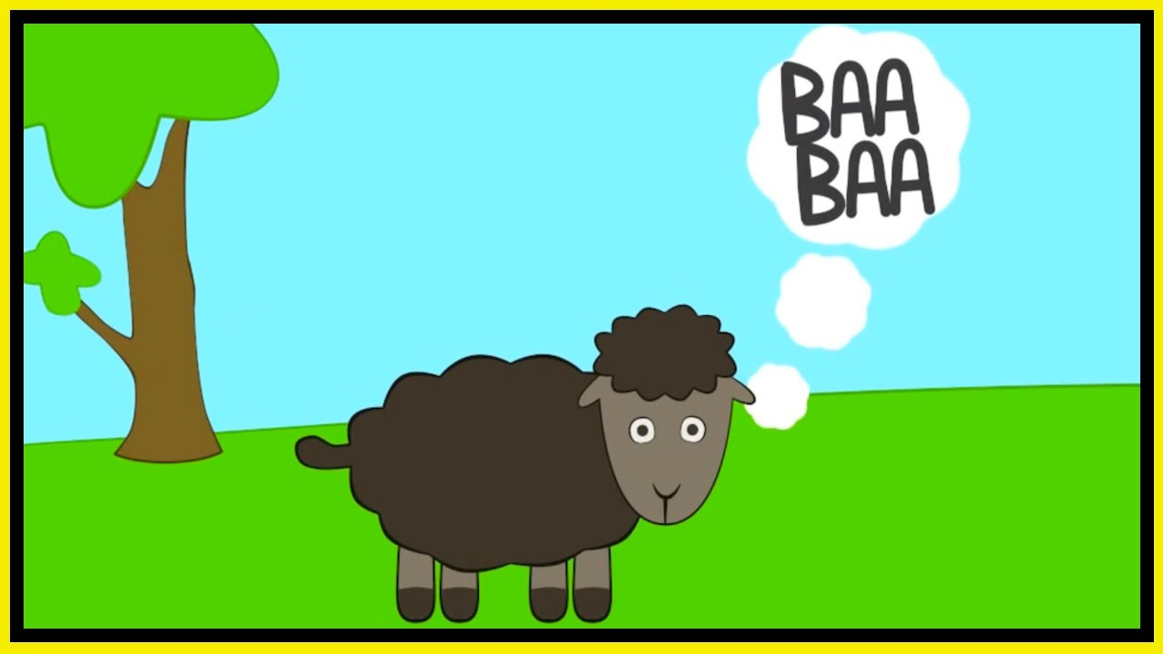

Twinkle little star.

How I wonder what you are.

Up above the world so high, like a diamond in the sky.

Twinkle little star.

How I wonder what you are. 

Twinkle little star. Twinkle Twinkle Little Star.

Head shoulders knees and toes, knees and toes.

Head shoulders knees and toes, knees and toes.

Head shoulders knees and toes, knees and toes.

Eyes and ears, mouth and nose.

Head shoulders knees and toes, knees and toes.

