To understand the Gulf Stream.

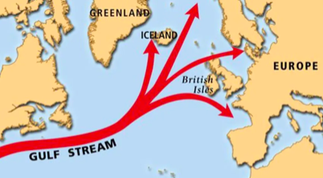

- What is the Gulf Stream?

- Where does the Gulf Stream begin?

- Why is the water warm in the Gulf Stream?

Challenge: Name the 4 places on the map where the Gulf Stream ends

