Nursery and Playgroup Learning

Start of the day – Try a different challenge each day and work towards doing all of these over the next two days.
- 5 hops on one foot then on the other foot
- 5 Jumps with both feet together
- 5 big steps
- 5 touching your toes and stretching up high
- 5 baby steps forward then backwards
Literacy – Use the PowerPoint and follow the story about Alfie gets in First.

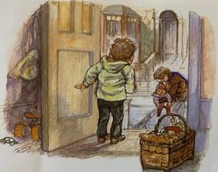
When you have shared the story talk to someone in your family about what happens in the story.
Can you remember the different characters in the story? Can you draw Alfie or one of the other characters?

Handwriting patterns – before following the handwriting pattern go over it with your finger first then with a pencil

Maths
- Share the PowerPoint of Five Little Ducks and with someone in your family try to sing this song together.
- Try to remember the rhymes we already know such as ‘Two little Dicly Birds sitting on a wall’ and ‘Humpty Dumpty’.
- With someone in your family count in whispers to five then in a big voice.
- With the help of an adult or someone in your family please log onto this website and do some counting with the ladybirds https://www.topmarks.co.uk/learning-to-count/ladybird-spots

Songs and rhymes log on and learn:  - Revisit - Jack and Jill Went up the Hill  - Sing and do the actions for – Five Little Monkeys jumping on the bed  - Sing and do the actions for Incy Wincy Spider  https://www.bbc.co.uk/teach/school-radio/nursery-rhymes-a-to-z-index/z4ddgwx | Remember the school website is:  http://www.moorside.newcastle.sch.uk/website  If you are stuck or want to send completed work then email  linda.hall@moorside.newcastle.sch.uk

