World Continents – Revision

Using the diagram and your own knowledge answer the questions and tick the correct answers.

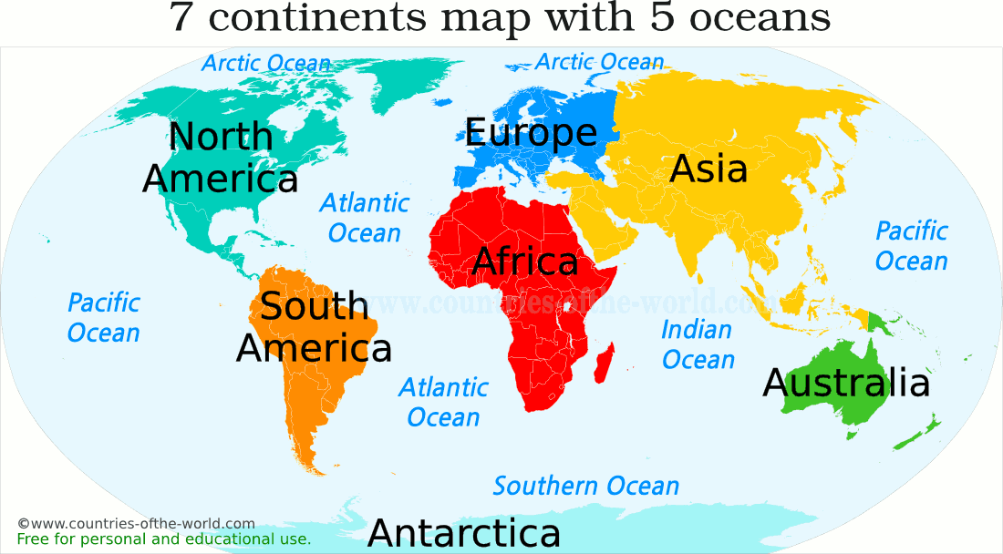

A globe is a model of the Earth. How many continents can you see on a globe?
Six
Seven
Eight

Which of these is NOT a continent?
Arctic
Asia
Antarctica
Which continent is the United Kingdom part of?
Europe
North America
Asia
Which continent is the largest?
Africa
Antarctica
Asia
Which continent is the coldest?
South America
Europe
Antarctica

