To develop my understanding of the South-East England

2) Why do you think the cliffs are white?
3) What do you think Vera Lynn is sing about?
4) What has happened and why do you think it has happened?
1) Draw an arrow where the White Cliffs of
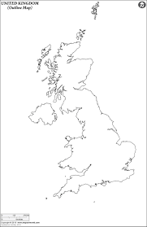
Dover are

