22.1.21 To explore changes within living memory
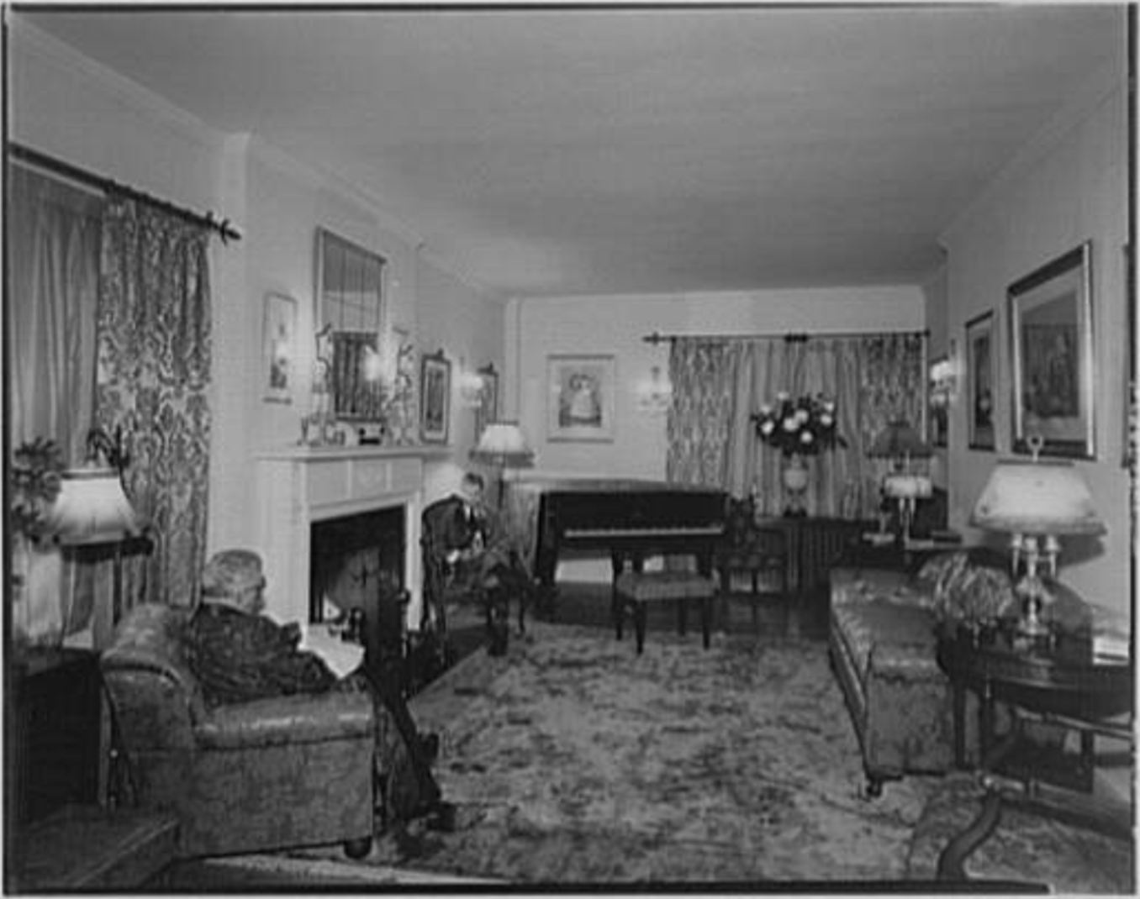
Key words: century (100 years ago), contrasts (what is different or has changed, how does the present day living room contrast with the past), connections (what is the same, what connections does the present day living room have with the past).
piano gas lamps seating fireplace special furnishings (rugs, pictures) wooden floor

Draw your idea for a present day living room below. What would be the same and different compared to a living room in the past? Challenge: can you label the objects in your living room and say what they are used for?

A living room in the past
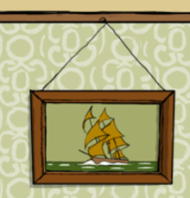
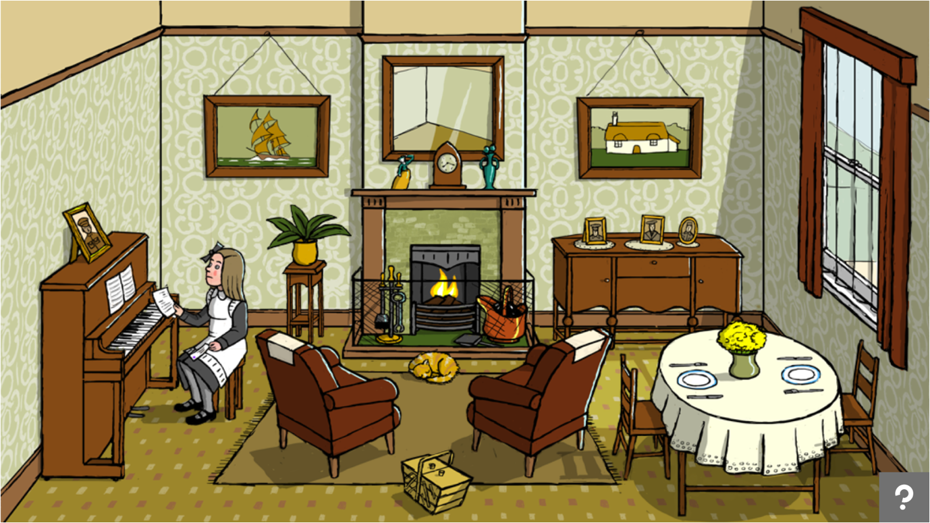
Pictures on the wall
People in the past used paintings or pictures to make their houses feel homely.

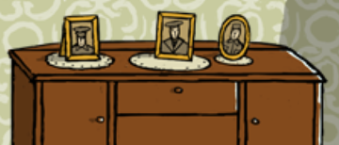
Photographs
It was unusual (not normal) to have lots of photographs as it cost a lot of money and normal people would not have a camera.
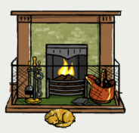
Fireplace
This was the only source of heating 100 years ago and burned wooden logs or coal.

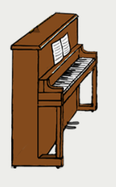
Piano
Not everyone had a radio at the time so this was the only way to listen to music. It was also something to do.

