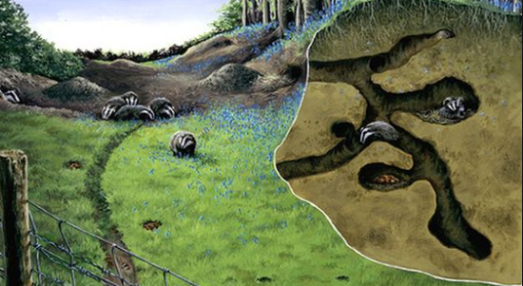
A Badger’s sett above ground and below the ground.

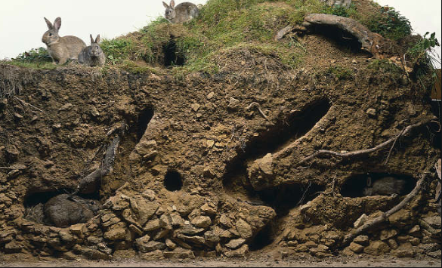
A rabbit’s burrow above ground and underground.

