**English: Verbs**

Can you make a poster with the verbs that you know?

sing

paint

jump

walk

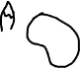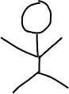

**Verbs**