Alternative English 2 - Rhyming and alliterative words
Choose three rhyming words for each picture. clown - frown
Choose three alliterative words for each picture. clown - cloud
Rhyming words | Alliterative words
Clown | Clown
frown | cloud
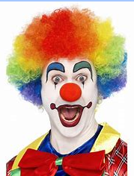
Rhyming words | Alliterative words
frog | frog
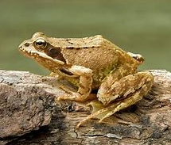
Rhyming words | Alliterative words
ship | ship

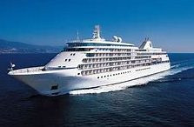
Rhyming Word Bank
goal frown dog under brown hip fog lip look smell
Alliteration Word Bank
egg shop fright hat friend close cloud catch shoot push

