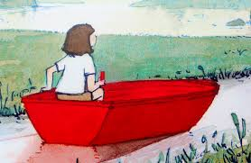
Reading: Character Work

Here is the girl from ‘Journey’.

Can you draw her and give her a name?

Describe her to a member of your family or add labels to your drawing.

