Alternative English - Identifying verbs
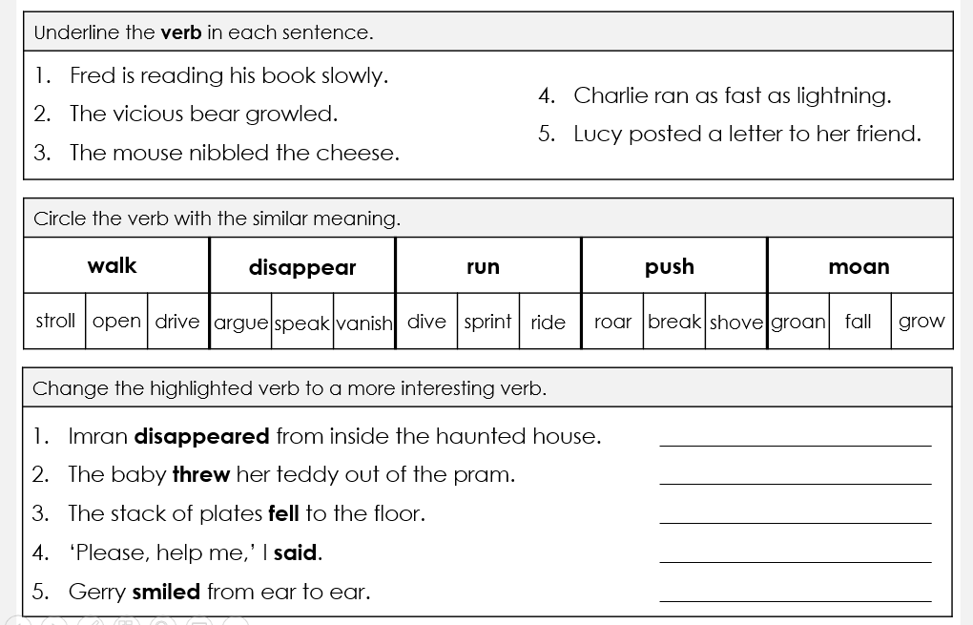
Use what you have learnt from the PowerPoint to identify and use the verbs below.

