Maths Alternative 2

Use yesterday’s PowerPoint to help.

Write the number sentence below each array.
The first one is done.

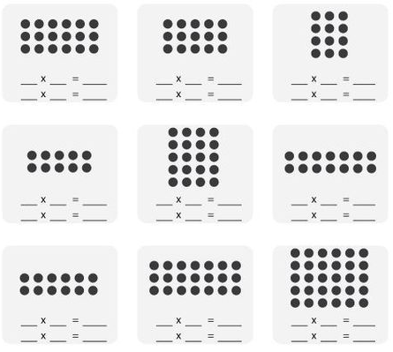
6 3 18

3 6 18

