Halving amounts

Use your understanding from yesterday’s lesson to find half of these amounts. Remember to use partitioning to complete them.
I have done one for you.

½ of 28 = 14 ½ of 46 = ½ of 52 = ½ of 38 = ½ of 90 =

28
20 8
10 4
14
Now complete these word problems using your understanding of ½ of amounts.

1. 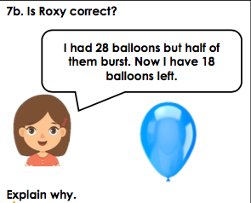 2. 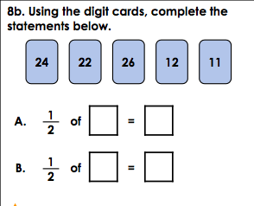

3. 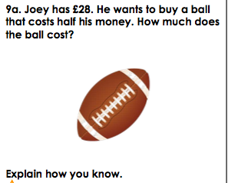 4. 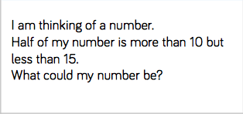

5. 