Learning intention: To identify that most living things live in habitats and explain what a habitat and microhabitat is.
Microhabitat quiz.
1. Where does a woodlouse get its food?
- from the air
- from the rotting wood
- from the soil
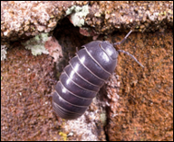
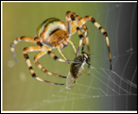
2. This spider catches flies in its web and eats them. Where is the best place for the spider to build a web?
- in the soil
- Inside a house
- on the outside of a house

3. Grace found a pile of old leaves. Where will she find the most minibeasts?
- on the leaves
- under the leaves
- in the air

4.Jack dug up some soil and found lots of earthworms. What type of place do earthworms like?
- light
- dark
- frozen

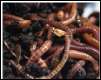
5. Ellis turned over an old log and saw lots of woodlice. What do woodlice need to live?
- just food
- just air
- food, water, ait and warmth
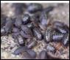
6. The place where minibeasts live is called a micro-habitat. What does micro mean?
- very big
- very small
- very large

