Learning intention – classifying animals based on their characteristics.
Use the list of animals you have been given, answer each question about the animals and put it into the correct box. When you have put all the animals into the correct box label the box with mammal, reptile, bird, fish or amphibian. Use the PowerPoint to help you do this.
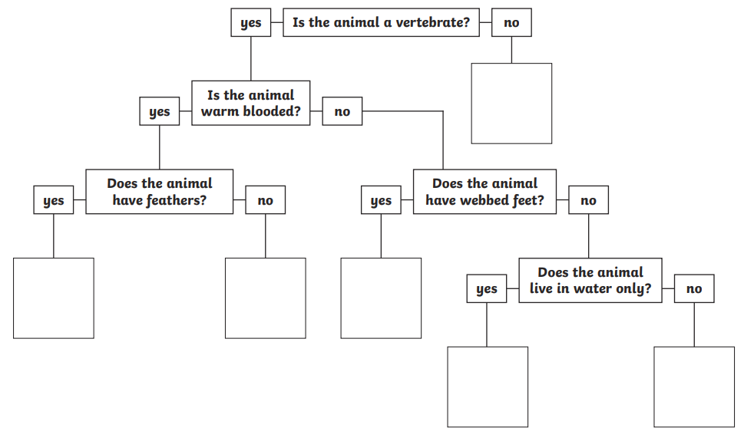

Remember a vertebrate is an animal with a backbone.

