Healthy relationships

Look at the pictures below and decide if each one shows a healthy or unhealthy relationship. Talk about each picture with someone in your home and write healthy or unhealthy on each line.

1. 2.

__________________________________ __________________________________

3. 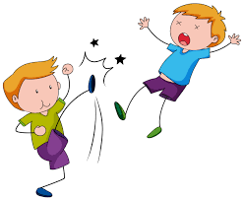 4.

__________________________________ __________________________________

5. 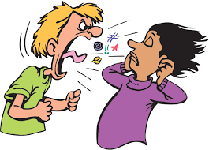 6.

__________________________________ __________________________________

