Alternative Maths 2
- How many are there?
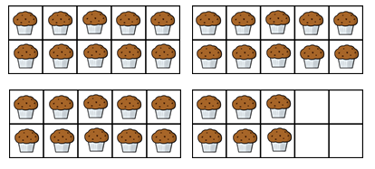

- Complete each number track
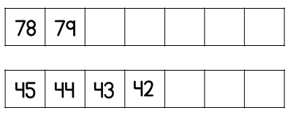

- Teddy makes this number
Rosie makes this number
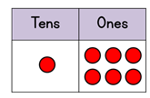
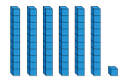

Tick () the right sentence
Teddy made the biggest number
Rosie made the biggest number
Teddy and Rosie made the same number

- Complete the sentence
7 tens is ____________________ 69
47 is _____________48
3 tens and 6 ones is _________________ thirty –six
Less than greater than equal to

- Compare the numbers using < > =
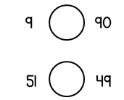

- Write the numbers in order start with the smallest
50 15 75 49

- Eva says
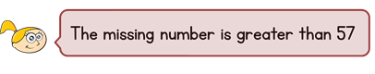
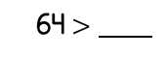
What could the missing number be?

