Blue and grey Thursday 4.2.21 Re-read the text from yesterday and complete this activity
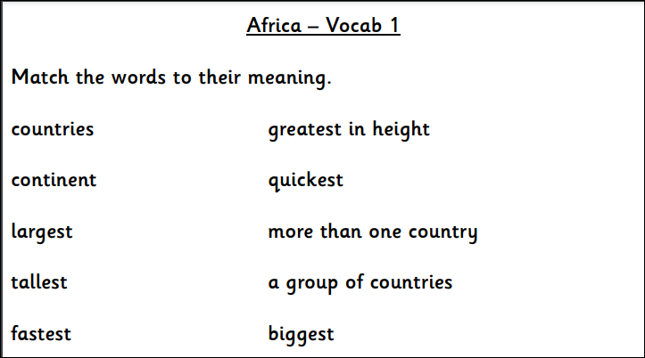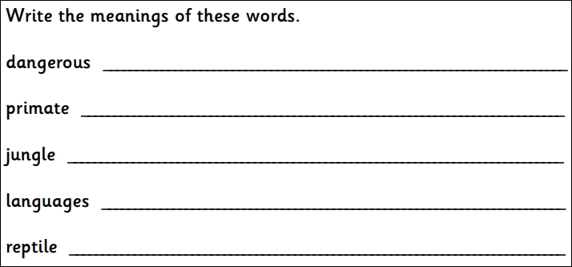

Write three questions about what you want to know about Africa.

