Missing number addition
Have a go at filling in the missing numbers in these addition sentences. There is a number line at the bottom to help you.

3 + = 6
1 + = 8
5 + = 6
2 + = 7
6 + = 10
4 + = 9
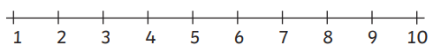
3 + = 8

