Identifying unit and non-unit fractions from visual representations
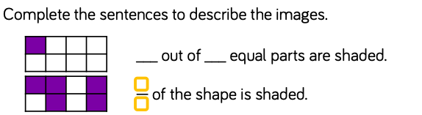
1)

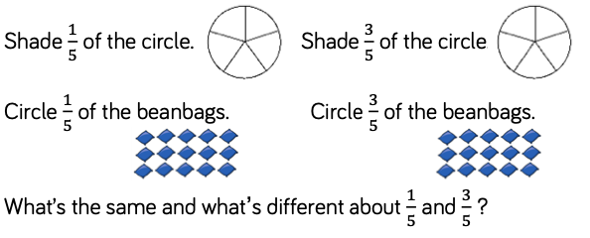
2)

…………………………………………………………………………………………………

…………………………………………………………………………………………………

3) Can you draw some examples of unit and non-unit fractions with the same denominator. For you could draw 1/5 and 3/5.

How many different pairs can you draw?

Challenge: Look at this ‘True or False’ statement, explain you answer.
